#### Downloading Eclipse

The following steps will install the Eclipse IDE and the JDK (Java Development Kit).

**STEP 1 Visit the Eclipse Web Site**

Open the following URL on your Web browser.

[**http://www.eclipse.org/downloads**](http://www.eclipse.org/downloads)



Click on the Eclipse Standard 4.4 link to open the download link page.

For the Eclipse Standard, select your operating system and either the 32 or 64 bit version to the right the page.

Once you are taken to the Eclipse download page, you can click the download link. The file size is near 200 megabytes.

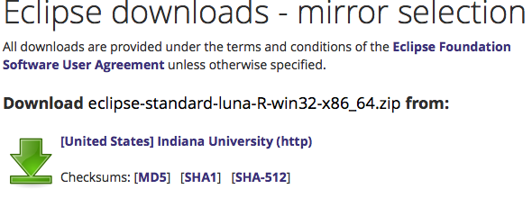

Click open the zip file when the download completes and copy the **eclipse** folder

to the root of your C: drive.

**STEP 2 Visit the Java Web Site**

With Eclipse loaded on your computer you can now visit the Oracle Web site to download the latest Java JDK ( Java Developers Kit ) .

[**http://www.oracle.com/technetwork/java/javase/downloads**](http://www.oracle.com/technetwork/java/javase/downloads)

Select the following icon to be taken to a page that lists the various platforms to download.

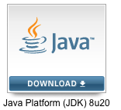

Review and accept the license agreement and then download the Java JDK 8 for your particular operating system.

When the download completes, double click the executable and load the jdk/jre

files to the default location listed which is typically under the directory

C:\Program Files\Java.

With both Eclipse and the JDK loaded you are now ready to program Java!